Autonomous Research Agent

Course Name: Agenitic AI

Institution Name: Medicaps University – Datagami Skill Based Course

Student Name(s) & Enrolment Number(s):
Sr no | Student Name | Enrolment Number
1 | Kunal Dhakad | EN22CS301534
2 | Kumar Saurav | EN22CS301531
3 | Krati Agrawal | EN22CS301513
4 | Kartikeya Parihar | EN22CS301490
5 | Khushi Karanjiya | EN22CS301503
6 | Kabir Kalani | EN22CS301474

Group Name: Group 09D5
Project Number: AAI-09
Industry Mentor Name: Aashruti Shah
University Mentor Name: Prof. Maya Yadav Baniya
Academic Year: 2025 -2026

Problem Statement & Objectives

Problem Statement:-

The technology industry is evolving at an unprecedented pace, driven by rapid advancements in Artificial Intelligence, Quantum Computing, Cybersecurity, Cloud Computing, and Emerging Digital Technologies. Organizations, startups, researchers, and investors require continuous and reliable technology intelligence to remain competitive and make informed strategic decisions.
However, traditional technology research methods are:
· Time-consuming and manual
· Scattered across multiple unstructured sources
· Lacking structured executive summarization
· Unable to maintain conversational research continuity
· Not scalable for rapidly evolving tech ecosystems
There is a strong need for an intelligent, autonomous research system capable of processing technology-related queries, navigating the web independently, synthesizing multi-source insights, and generating structured professional reports while maintaining historical knowledge for future reference.

Project Objectives

The primary objectives of this project are:
- To develop an LLM-powered Autonomous Research Agent.
- To enable conversational technology intelligence generation.
- To implement a Python-based backend research engine.
- To design an interactive Streamlit-based frontend dashboard.
- Toutilize Grok LLM for intelligent synthesis and report generation.
- Toallow autonomous web research using integrated search tools.
- To synthesize insights from multiple high-quality technology sources.
- To automatically generate structured professional research reports.

Scope of the Project

The scope of the project includes:
· Technology trend analysis
· Emerging technology monitoring
· AI, Cybersecurity, Cloud, Quantum, Web3 research
· Growth trend identification
· Risk and opportunity assessment
· Strategic recommendation generation
· Conversational multi-turn research
· Knowledge storage and retrieval
The project specifically focuses on the technology industry and does not include:
· Real-time stock trading systems
· Direct enterprise ERP integration
· Financial transaction systems
· Live hardware-level monitoring

Proposed Solution
The proposed solution is an AI-powered Autonomous Tech Trends Research Agent built using:
· Grok Large Language Model (LLM)
· Python backend
· Streamlit frontend
· Web search integration tools
· Text-based knowledge repository

Working Mechanism:
The user submits a technology-related query via the Streamlit dashboard.
- The backend processes the query using Python.

- The system retrieves prior research context (if available).

- The agent autonomously performs web research using integrated search tools.
- Multiple sources are analyzed and synthesized using Grok LLM.
- The LLM generates a structured research report including:
· Executive Summary
· Key Technology Trends
· Major Insights
· Notable Companies/Innovations
· Risks & Challenges
· Strategic Recommendations
The final report is formatted and stored in a text-based knowledge repository.
The user can access previous research outputs from the dashboard.
This creates a fully automated technology intelligence pipeline.
- Key features
· Autonomous Web Research Capability
· AI-Powered Multi-Source Synthesis
· Grok LLM-Based Insight Generation
· Streamlit Interactive Dashboard
· Context-Aware Research Flow
· Structured Executive-Level Report Generation
· Technology Trend Monitoring
· Risk & Opportunity Identification
· Text-Based Knowledge Repository
· Search History Retrieval
· KPI-Based Trend Display

- Overall Architecture / Workflow

1. User Interface Layer (Frontend)
Built using Streamlit
· Accepts natural language queries
· Displays structured research reports
· Shows previous research history
· Displays technology trend insights
· Interactive user dashboard

2. Application Layer (Backend)
Developed using Python
· Handles user queries
· Coordinates research workflow
· Manages data processing
· Controls LLM interaction (Grok API)
· Stores reports in repository

3. Intelligence Layer (LLM + Research Engine)
Grok LLM:
· Synthesizes multi-source information
· Generates structured reports
· Produces executive-level insights
· Identifies patterns and trends
Research Engine:
· Conducts web search
· Extracts relevant content
· Filters noise
· Sends structured prompts to Grok

4. Data Layer (Knowledge Repository)
Stores:
· User queries
· Generated reports
· Timestamps
· Historical research logs
Enables retrieval of past research and trend tracking.

3. Tools & Technologies Used
Programming Language:
· Python

AI & Model:
· Grok LLM
Frontend:
· Streamlit
· HTML/CSS Styling
Backend:
· Python-based research engine
Database / Storage:
· Text-based knowledge repository
Libraries:
· Requests
· Pandas
· DateTime
· JSON
· OS

Results & Output
The developed system successfully:
· Processes natural language technology queries
· Conducts autonomous web research
· Synthesizes insights from multiple sources
· Generates structured professional tech trend reports
· Maintains research continuity
· Stores reports for future reference
· Displays technology intelligence insights via dashboard
The agent significantly improves efficiency compared to manual research processes.

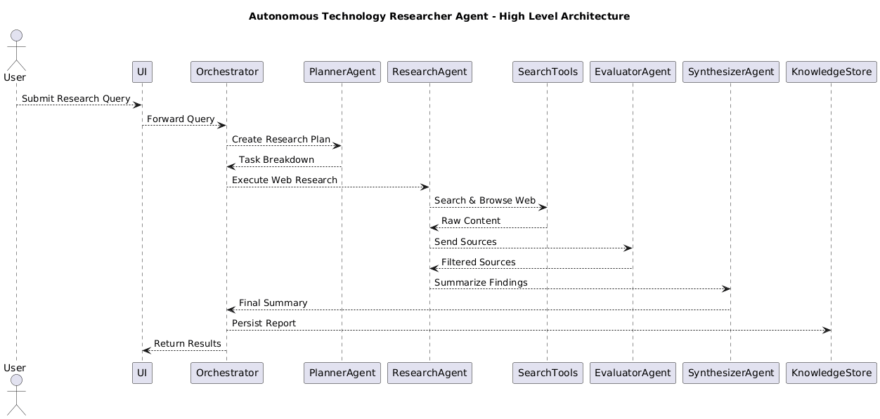

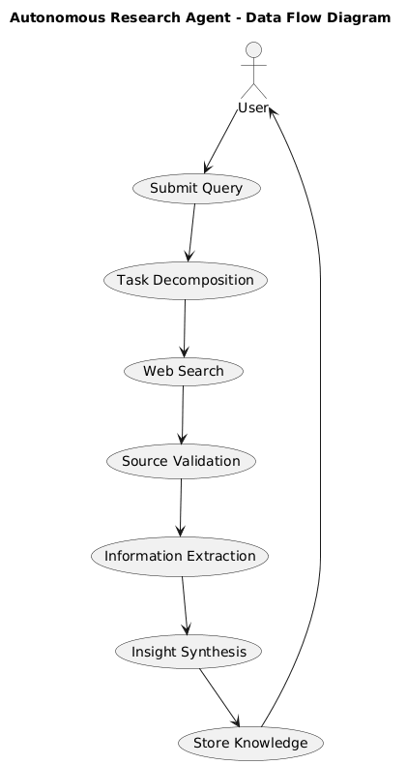

Details here:

1. Screenshots / Outputs
(Insert screenshots of:)
· Streamlit Dashboard Interface
· Tech Query Input System
· Structured Technology Trend Report
· Research History Sidebar
· Backend Running Console
· Knowledge Repository File

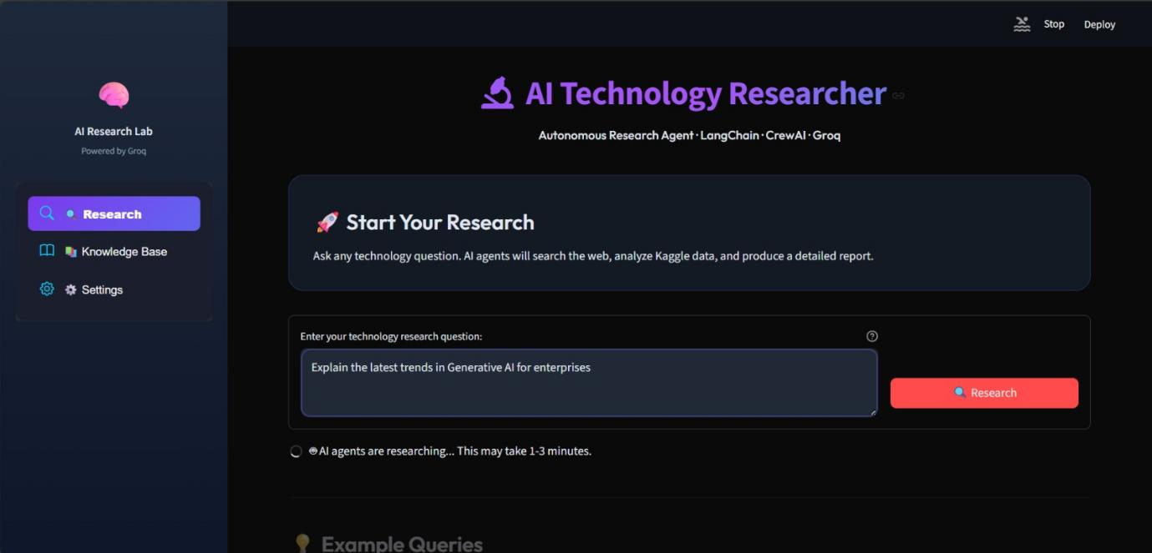

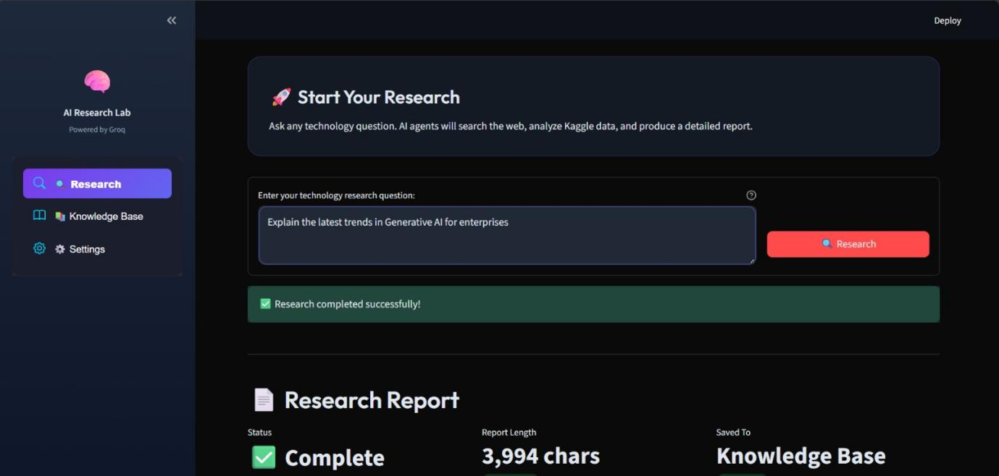

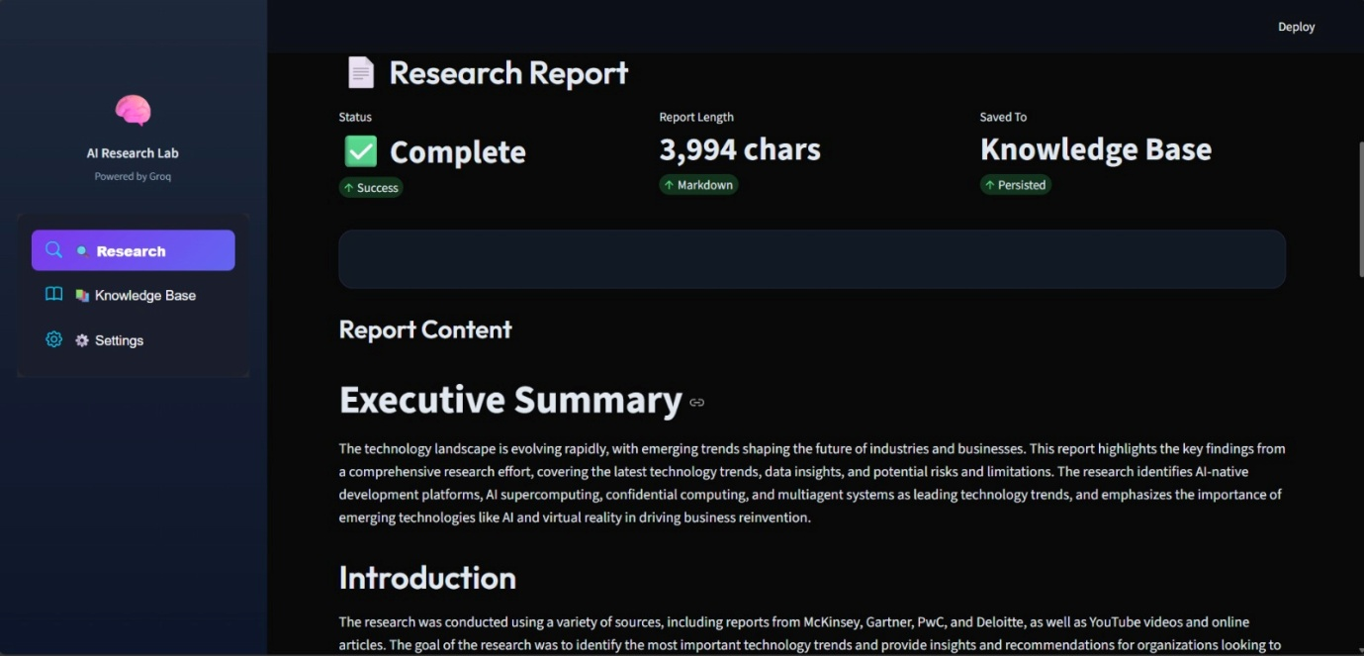

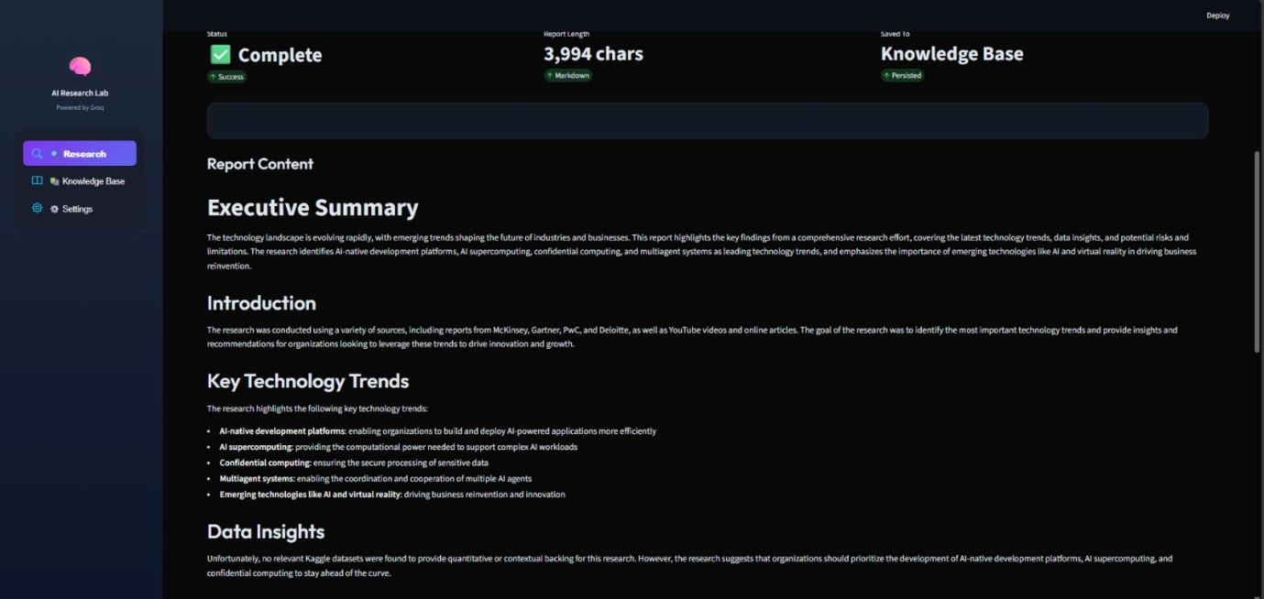

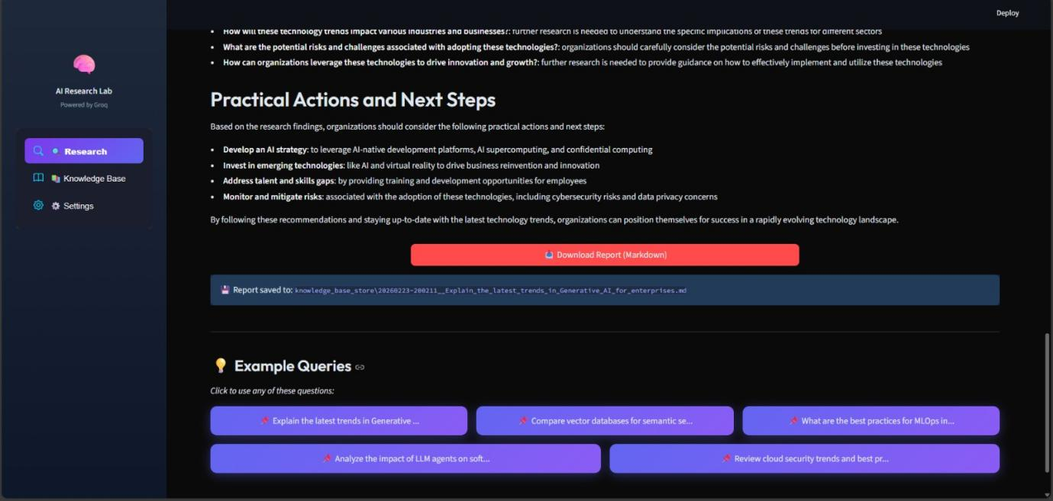

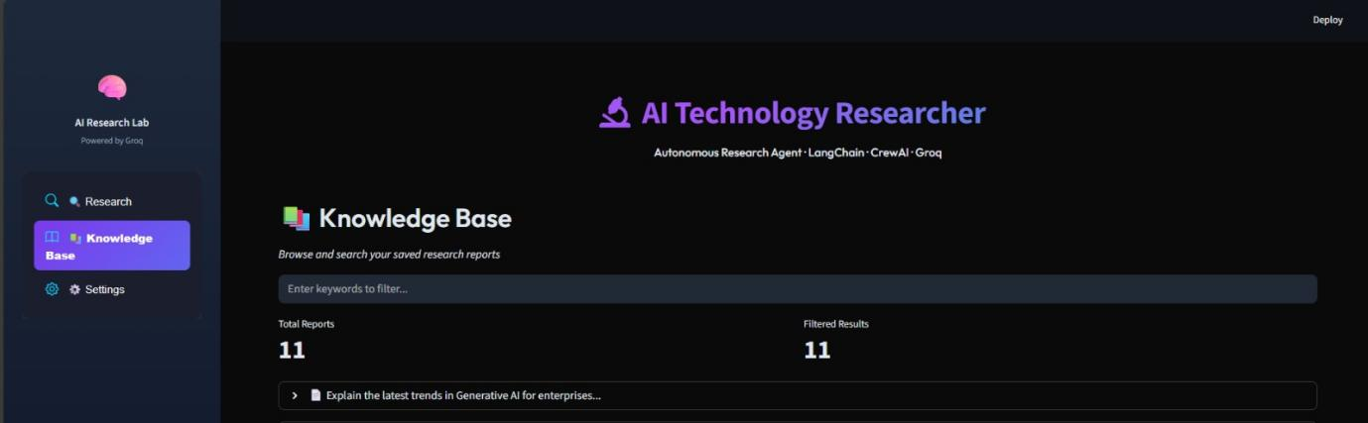

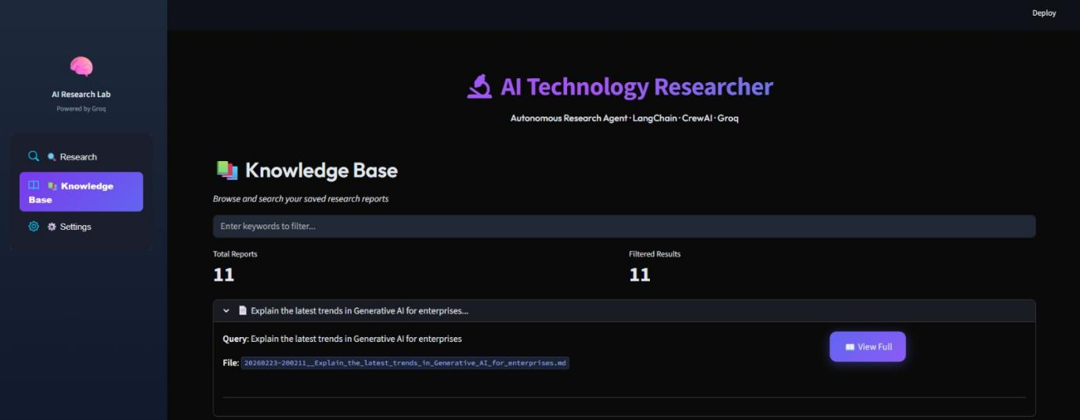

- Reports / dashboards / models
· Executive Technology Intelligence Reports
· AI Industry Trend Reports
· Cybersecurity Trend Reports
· Cloud & Quantum Technology Reports
· Emerging Tech Risk Analysis Reports

- Key outcomes

· Automated technology market intelligence generation
· Reduced manual research effort by approximately 70–80%
· Structured executive-level reporting
· Improved decision-support capability
· Practical implementation of Grok LLM integration
· Demonstration of AI-driven research automation.

- Conclusion

The Autonomous Tech Trends Research Agent successfully integrates Grok LLM, Python backend processing, and Streamlit frontend interface to build an intelligent, scalable, and automated research system tailored for the technology industry.
The project demonstrates how AI can transform traditional technology research workflows by enabling autonomous web navigation, structured insight synthesis, and conversational intelligence.
Key learnings from this project include:
· LLM-based research automation
· Prompt engineering with Grok
· Python backend system design
· Streamlit dashboard development
· Knowledge persistence implementation
· Structured report generation

s

The system establishes a strong foundation for AI-powered technology intelligence automation.

Future Scope & Enhancements
· Integration with real-time tech news APIs
· Vector database implementation
· Semantic search over historical reports
· Predictive trend analysis
· AI-powered visualization dashboards
· Sentiment analysis of technology news
· Cloud deployment (AWS / GCP / Azure)
· Multi-industry expansion beyond technology
· Role-based authentication system
· Automated weekly technology intelligence reports

